Code:

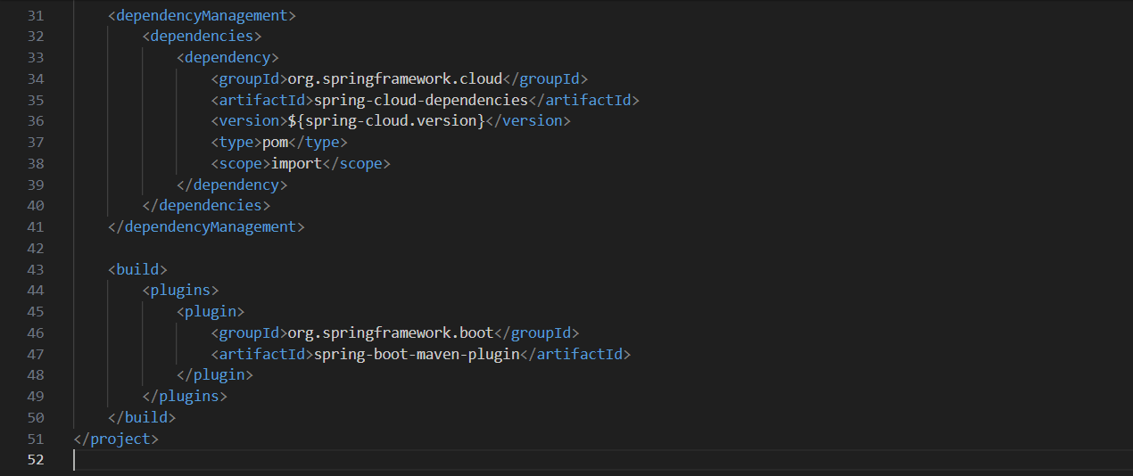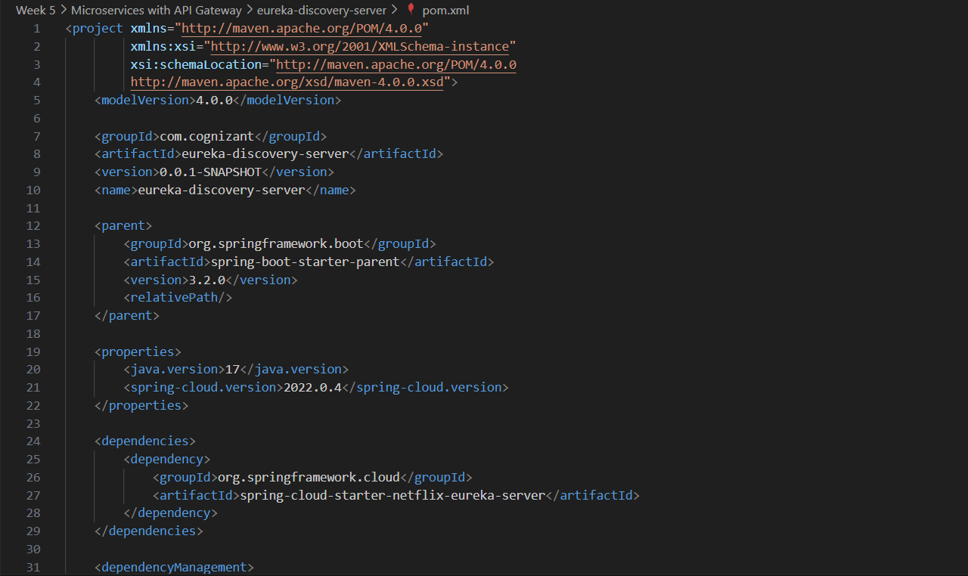pom.xml

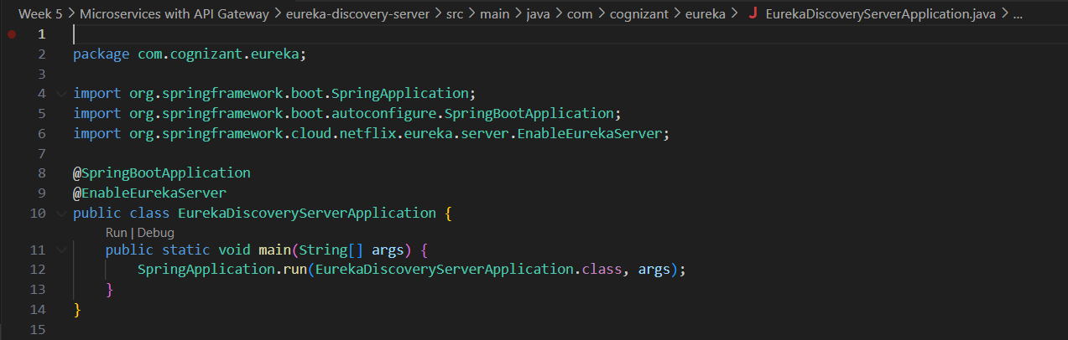EurekaDiscoveryServicesApplication.java

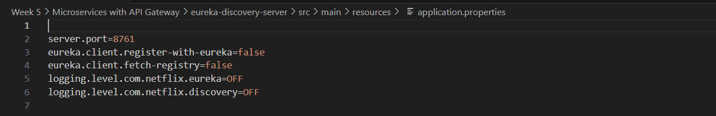application.properties